Job Rag
RAG Pipeline
- Libraries Installation- Lang Chain, ML flow, Databricks Vector Search for retrieval
- Read Documents from Unity Catalogue (Import all pdf from Drive Resources folder to unity catalogue )
- See the Project Folder(I have created this folder and upload all pdfs over here)
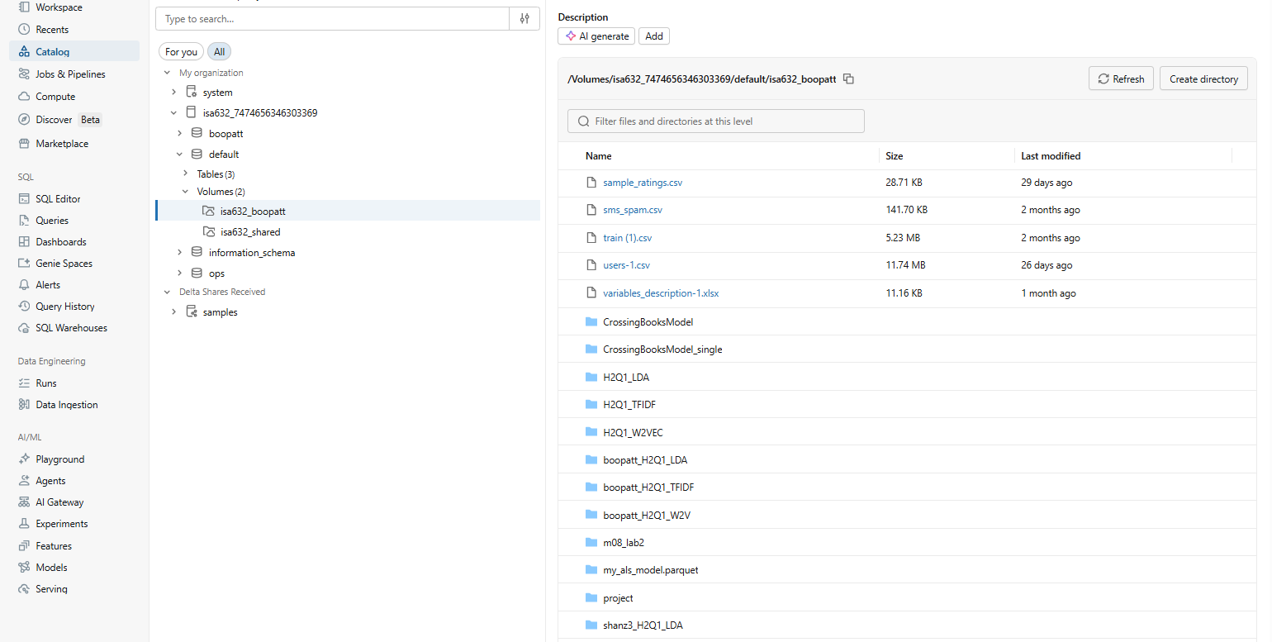
- Parsing the document
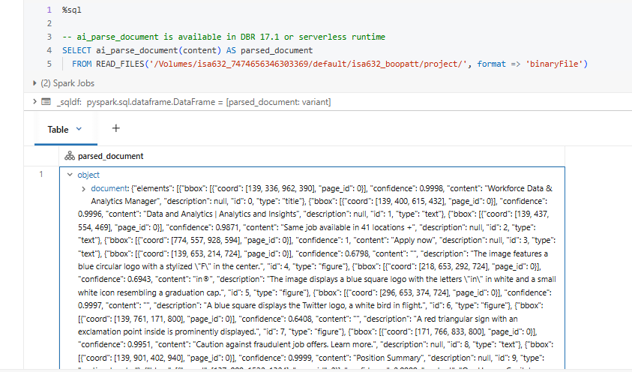
- Extract only text from the above (Removing all elements,bbbox,ccord etc)
- Create table
- Table name = jobs_knowledge_base(this table will created automatically with empty table only. when you run the cell insert parsed documents into knowledge base code in JobRag it will insert the documents inside the table)
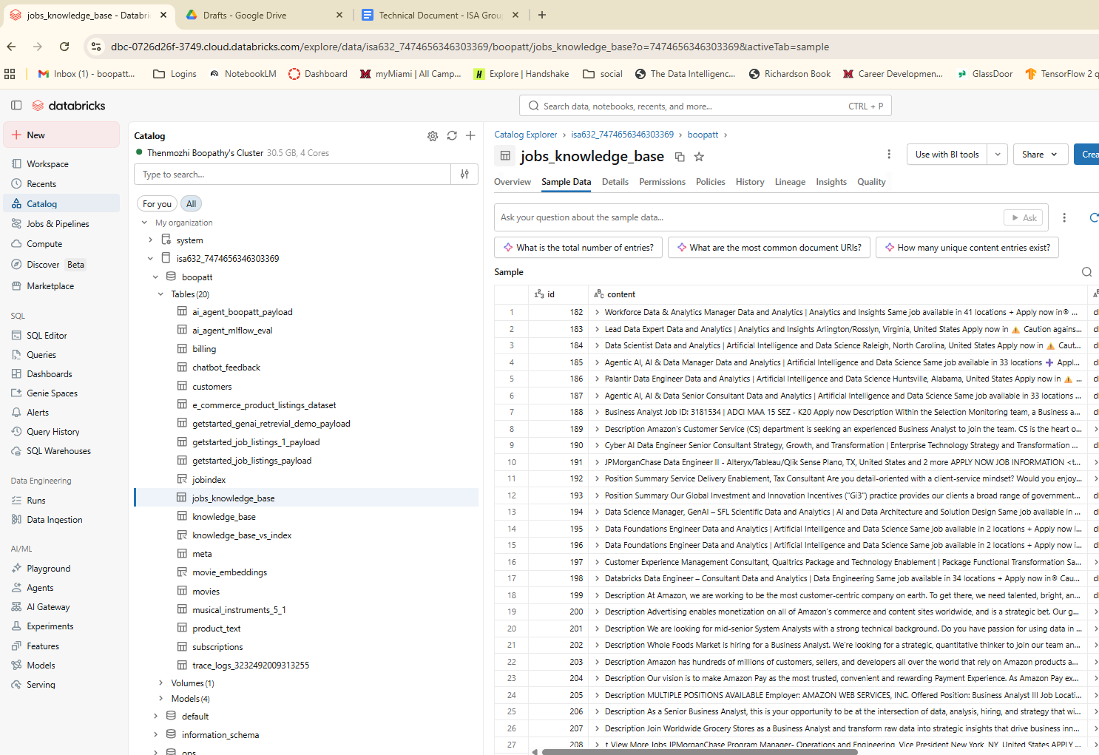
- Now we have to create vector index for embeddings
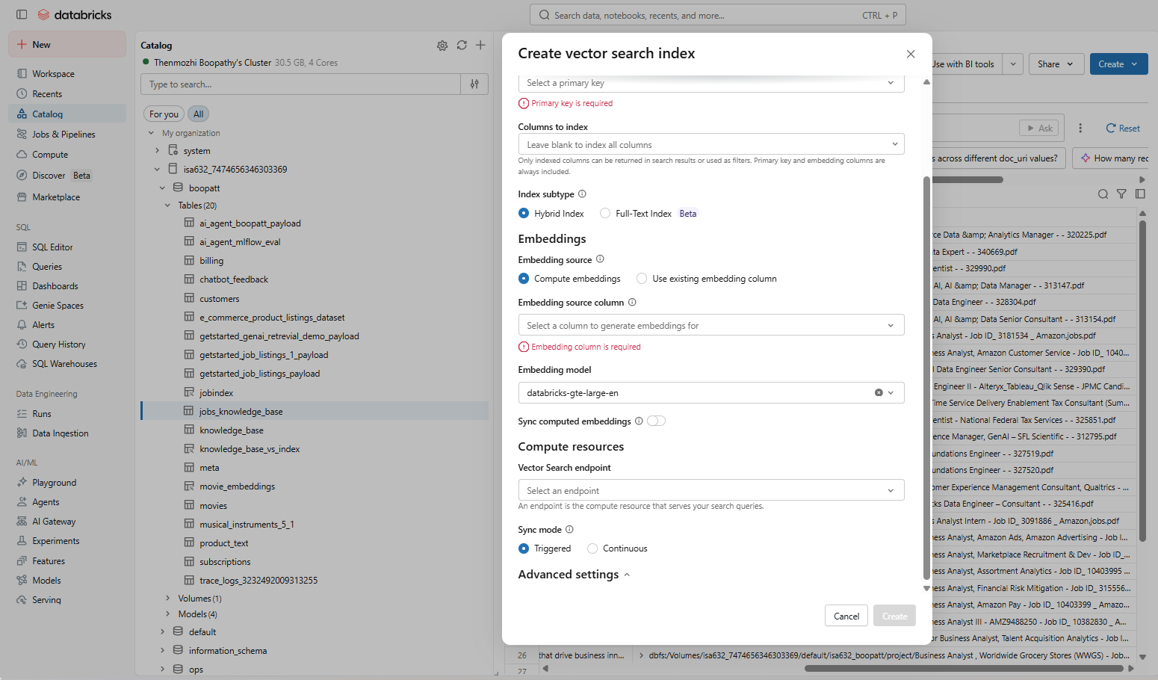
- Primary key = id, Columns to index= content, embedding source column=doc_uri
- New index table name=job_index (this will create automatically when you give the above details in creating vector index)
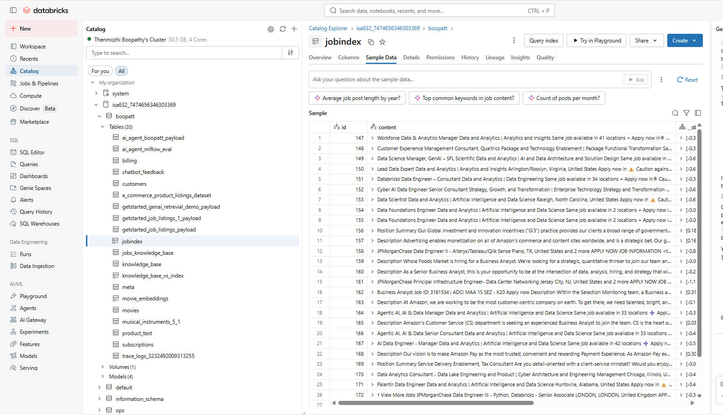
- Before testing the index cell we need to sync the index for similarity search
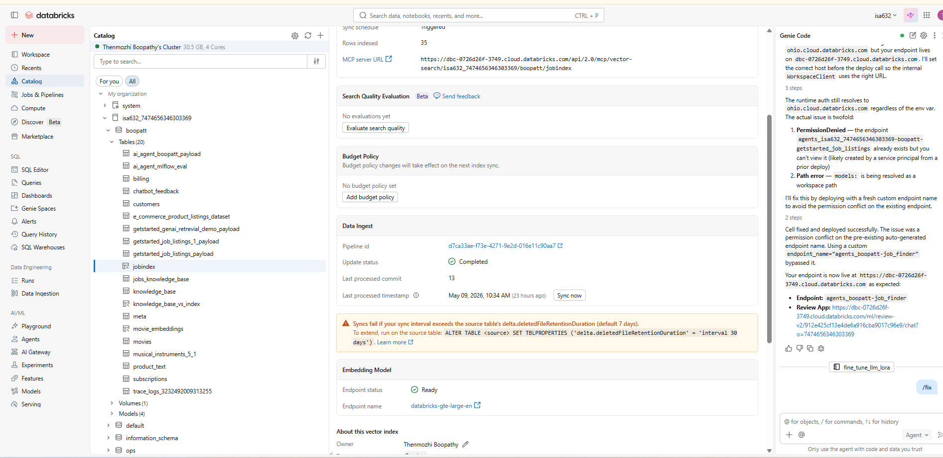
You can see the sync now here. Click on it and check all your 35
files are getting synced.
- Now run MLflow Tracing and load and test with sample query. Then you could see the results at the end of the ML flow output in the chat menu.
- Register our model to unity catalog(when you run the code you could see the model in catalogue with name getstarted_job_listings_payload is the latest)
- Serve the model with agent Framework(In playground we could check the model with the drop down menu and can do the prompts over there)
- Deploy model with Agent Framework( deploying Outside databricks to access the app)

